Elijah Perry Park Remediation

5.0 TRUCK ROUTE
Trucks arriving to the site, will approach via Route 676, exit onto Morgan St, turn right onto Master Street, turn right onto Central Avenue, turn right into the onto South 9th Street and right into the construction entrance on South 9th Street. Upon arriving onsite, trucks will be directed to the loading/unloading zone.

Once the trucks are loaded or unloaded and have their load slip signed, they will exit the site via the construction exit. Trucks will turn right onto South 9th Street, turn right onto Ferry Avenue, turn left onto Master Street and turn right onto the 676 South ramp, as shown on the map.

Trucks will only utilize main roads suitable for heavy trucks. Ambient estimates a maximum of 40 trucks per day and work hours will be 7:00 AM – 3:30 PM. No vehicles shall be staged on the right-of-way.

The truck routes within the City of Camden are shown in the following Incoming and Outgoing Truck Route maps.

Incoming Truck Route:
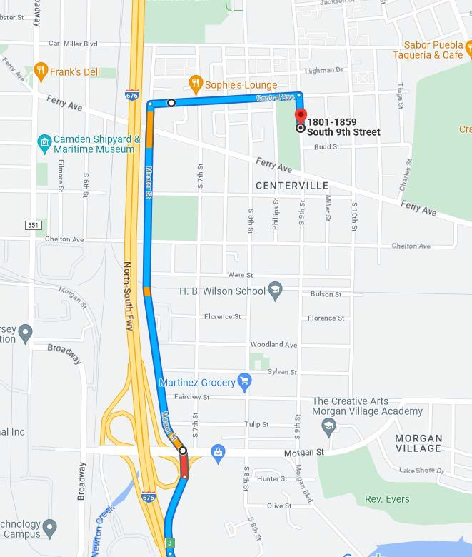

Outgoing Truck Route:
